Scripting Task

Task Description:

- Create a shell script to print the HTTP error code of guvi.in & print, the success/failure message based on the error code response

Step 1:
Shell Script to print the HTTP error code of guvi.in
#!/bin/bash
status_code=$(curl -o /dev/null -s -w "%{http_code}" https://www.guvi.in)
echo "HTTP Status Code: $status_code"

if [ "$status_code" -eq 200 ]; then
echo "Success: Website is reachable."
elif [ "$status_code" -ge 400 ] && [ "$status_code" -lt 600 ]; then
echo "Failure: Website returned an error."
else
echo "Warning: Unexpected response."
fi

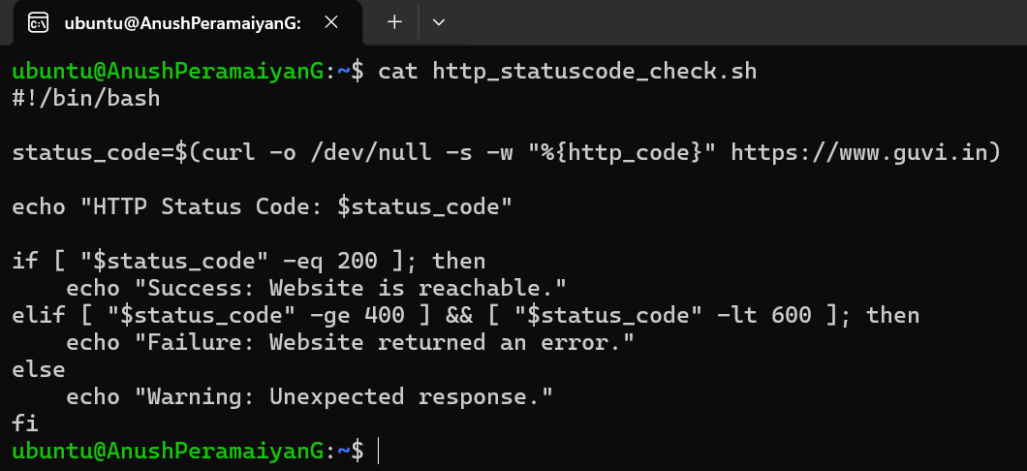
Step 2:
Make the script as executable
chmod u+x http_statuscode_check.sh
./http_statuscode_check.sh
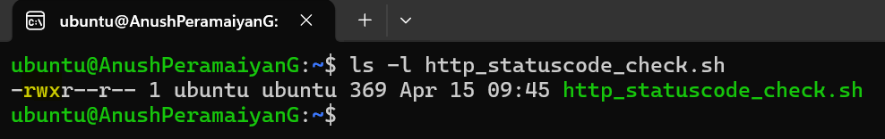

Step 3:
Execute the Script
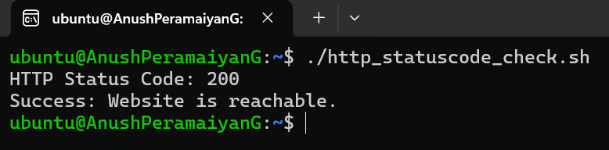

OUTPUT:
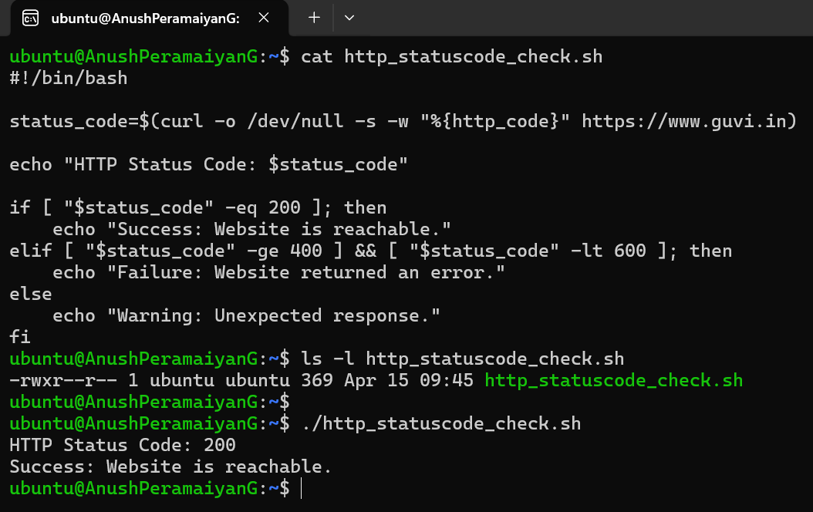
- Given a file, replace all occurrence of the word "give" with "learning" from 5th line till the end in only those lines that contain the word "welcome"
Step 1:
Create a text file with respective word
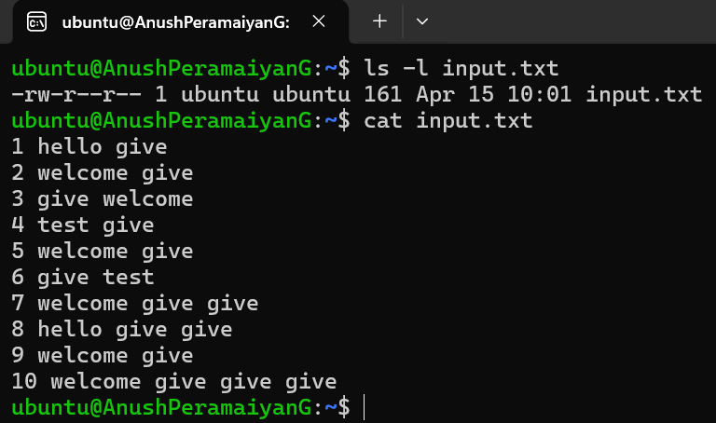
Step 2:
Execute sed command to do the given task
Command: sed '5,$ {/welcome/ s/give/learning/g}' input.txt > output.txt
Step 3:
OUTPUT:
